Page last updated at 09:11 GMT, Wednesday, 20 January 2010, bbc.co.uk

South Koreans told to go home and make babies
By John Sudworth
BBC News, Seoul
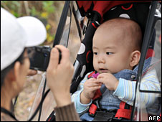
South Korea has one of the world's lowest birth rates
South Korean government workers are being presented with an unusual suggestion - go home and multiply.
At 1900 on Wednesday, officials at the Ministry of Health will turn off all the lights in the building.
They want to encourage staff to go home to their families and, well, make bigger ones. They plan to repeat the experiment every month.
A ministry spokesman told the BBC that "Family Day" would encourage staff to spend a little more time at home.
By helping staff who work long hours to rediscover the importance of family, the hope is policy might have an impact on birth rate, even if only indirectly.
The country has one of the world's lowest birth rates, lower even than neighbouring Japan.

Boosting the number of newborn children is a priority for the government, which is staring into the abyss of a rapidly ageing society, falling levels of manpower and spiralling health care costs.
The Ministry of Health, now sometimes jokingly referred to as the Ministry of Matchmaking, is in charge of spearheading this drive, and it clearly believes its staff should lead by example.
Generous gift vouchers are on offer for officials who have more than one child, and the department organises social gatherings in the hope of fostering love amongst its bureaucrats.
But critics say what is really needed is widescale reform to tackle the burdensome cost of childcare and education that puts many young people off starting a family.

